|  |  |  |  |  |
| --- | --- | --- | --- | --- |
| EGC_Black | | Mathematics Essentials 2017  Test 3  Task Weighting: 8% | | |
| Student Name: |  | | TOTAL = /63 |

Time Allowed: 15 Minutes Marks: 19

**Calculator Free** - **No calculator or notes permitted for this section.**

***Answer all of the following questions. Show all working to obtain full marks.***

**Question 1** [6 Marks]

Complete the missing values to make the conversions true

|  |  |  |  |  |  |  |  |
| --- | --- | --- | --- | --- | --- | --- | --- |
| **a** | 6.23 kilograms = |  | grams | **d** | 5400 joules = |  | kilojoules |
| **b** | 40 cm3 = |  | mm3 | **e** | 96 kJ = |  | calories |
| **c** | 70000 cm3 = |  | m3 | **f** | 0.812 kW = |  | watts |

**Question 2** [1 marks]

Calculate the volume of the prism by counting the cubes.

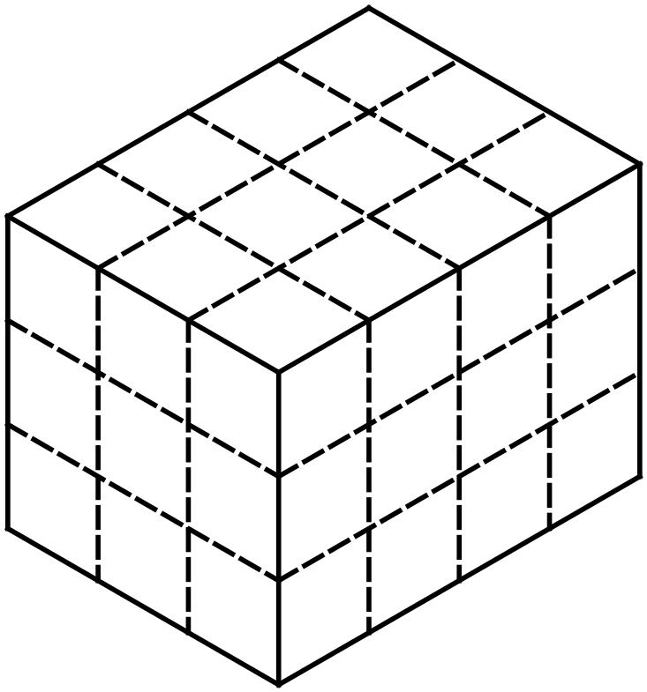

\_\_\_\_\_\_\_\_\_\_\_\_ cubes

**Question 3** [7 Marks – 1, 1, 2, 3]

Below are the results of a survey, gathered by a Kalgoorlie phone shop. They were looking at the phone ownership of two major phone brands.

**Mobile Phone Owners.**

|  |  |  |  |
| --- | --- | --- | --- |
| **Type of Phone** | Male | Female | Total |
| **iPhone** | 36 | 50 | 86 |
| **Samsung** | 22 | 45 | 67 |
| **Total** | 58 | 95 | 153 |

a) Which brand was the most common?

b) How many males own a Samsung phone?

c) Would a line graph be suitable to display this data? Explain why or why not.

d) The shop wishes to purchase two (2) different styles of phone covers. There are four (4)

to choose from  
  
 - green sparkly **OR** - blue **OR** - pink sparkly **OR** - red

Which two (2) would they choose? Explain your choices.

**Question 4** [5 Marks – 1, 1, 1, 2]

The column graph below shows the **average monthly rainfall** in Perth, in mm.



a)Which month had the highest average monthly rainfall?

b)Which month had the lowest average monthly rainfall?

c)What was the average monthly rainfall for April?

d)Estimate thetotal rainfall for the year?

Time Allowed: 45 Minutes Marks: 44

**Calculator Assumed - Calculators and files are allowed in this test.**

***Answer all of the following questions. Show all working to maximise marks.***

### Question 7 [9 marks: 1, 1, 1, 2, 2, 2]

John Applecore began his apple orchard in 1996. The first apples were picked in 1999. The graph below shows the harvest for 5 years.

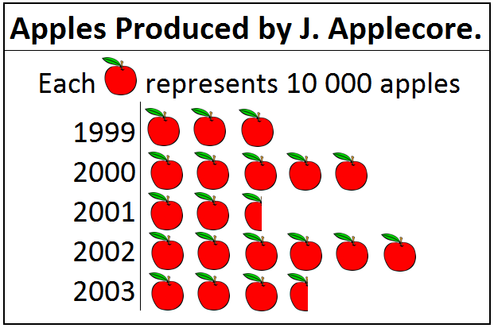

a) What kind of graph is this?  
  
  
b) In which year was the harvest greatest?

c) What was the harvest in 2003?

d) Which year did the harvest increase the most? Justify your answer.

e) What percentage of the apples picked between 1996 and 2000 were picked in 1999?

f) In 2003 John paid Julie 20 cents per apple to pick the complete harvest. How much

was she paid?

### Question 8 [6 marks]

Below is a table with Tanya’s height at each birthday from 2 years to 16 years old. Each height has been measured to the nearest centimetre.

|  |  |  |  |  |  |  |  |  |  |  |  |  |  |  |  |
| --- | --- | --- | --- | --- | --- | --- | --- | --- | --- | --- | --- | --- | --- | --- | --- |
| Age in years | 2 | 3 | 4 | 5 | 6 | 7 | 8 | 9 | 10 | 11 | 12 | 13 | 14 | 15 | 16 |
| Height  (cm) | 86 | 94 | 103 | 108 | 115 | 121 | 128 | 133 | 140 | 147 | 154 | 158 | 163 | 165 | 166 |

Use the grid below to graph the above information.

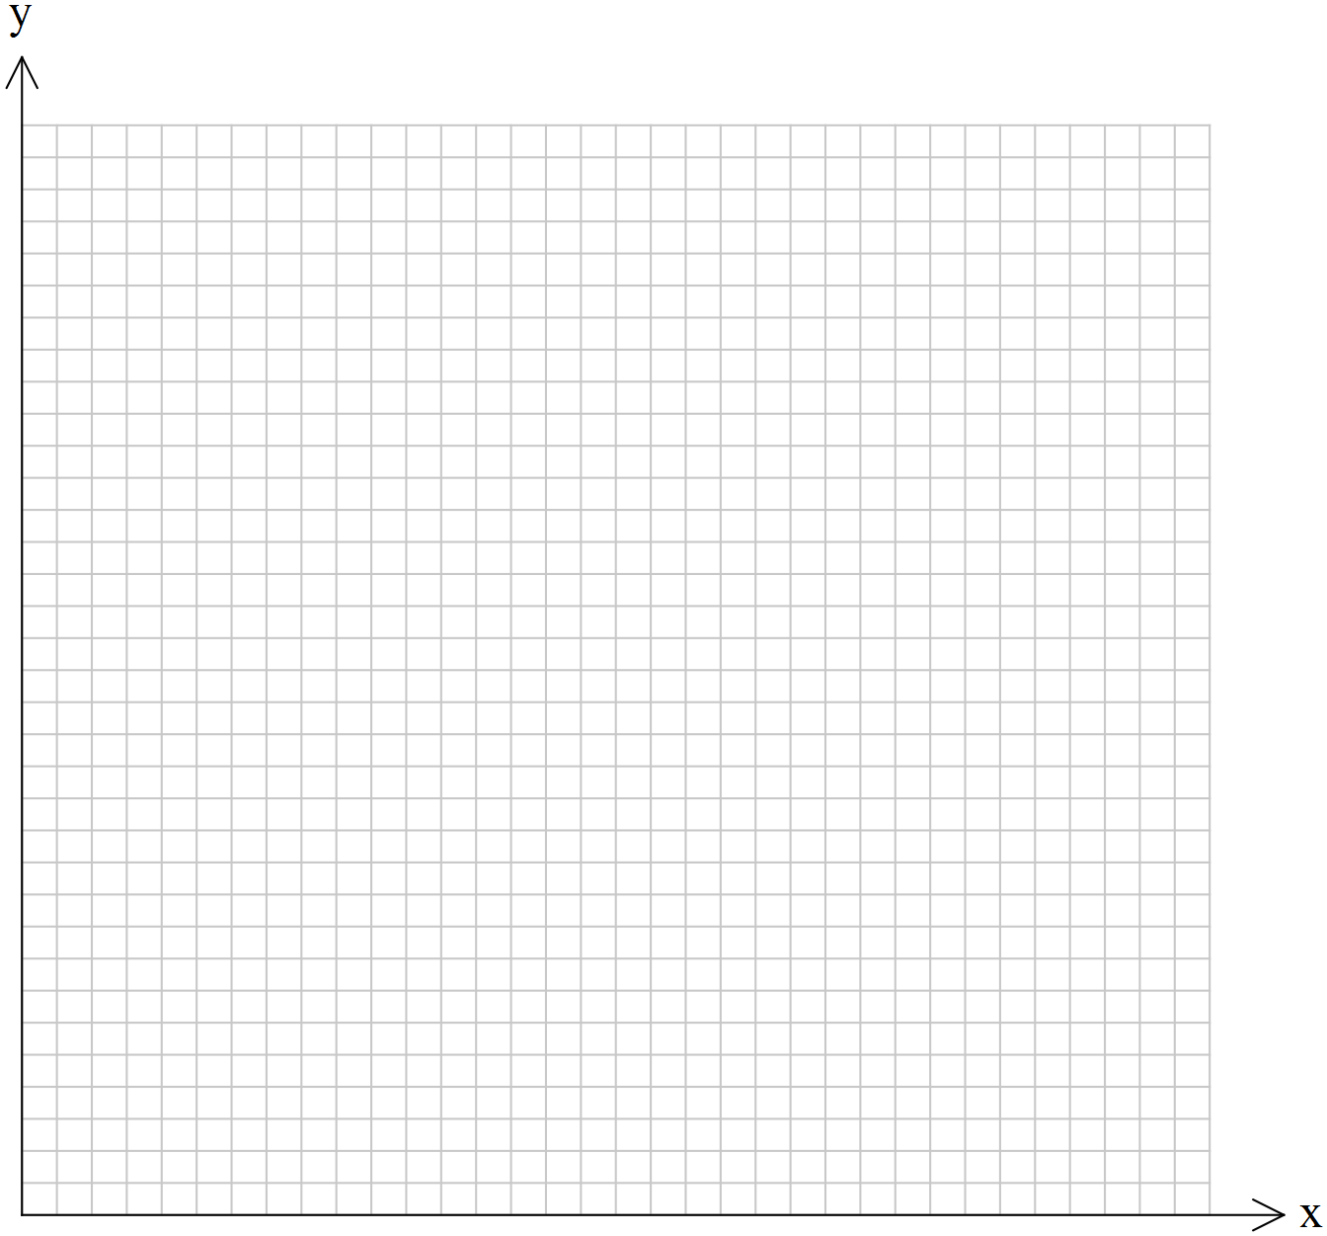

**END OF TEST**

**Question 9** [5 Marks: 1, 1, 3]

Anne has a clothes dryer that is rated at 2350 watts and is used for about half an hour each morning during summer.

a) Convert 2350 watts to kilowatts

b) What is the total number of kilowatt hours used by the dryer in one week.

Anne is concerned about her electricity usage (consumption) during the winter. She decides to compare her electricity bill to her neighbour Bob, who has the exact same model of dryer. Both use their dryers for **1.5 hours** each day during winter. Anne puts hers on at **10 am** whilst Bob turns his on at **5pm**.

**On-Peak Electricity Time = 2pm – 7pm charged at 49.3 cents per kWh.**

**Off-Peak Electricity Time = 9am – 12pm charged at 13.6 cents per kWh.**

c) Use the information above and below to determine who is charged the least and

whether or not Anne should be concerned about her electricity usage.

Explain your answer with the support of a mathematical calculation.

**Question 10** [4 Marks: 2, 2]

Calculate the volume of these prisms showing all your working.

a) b)

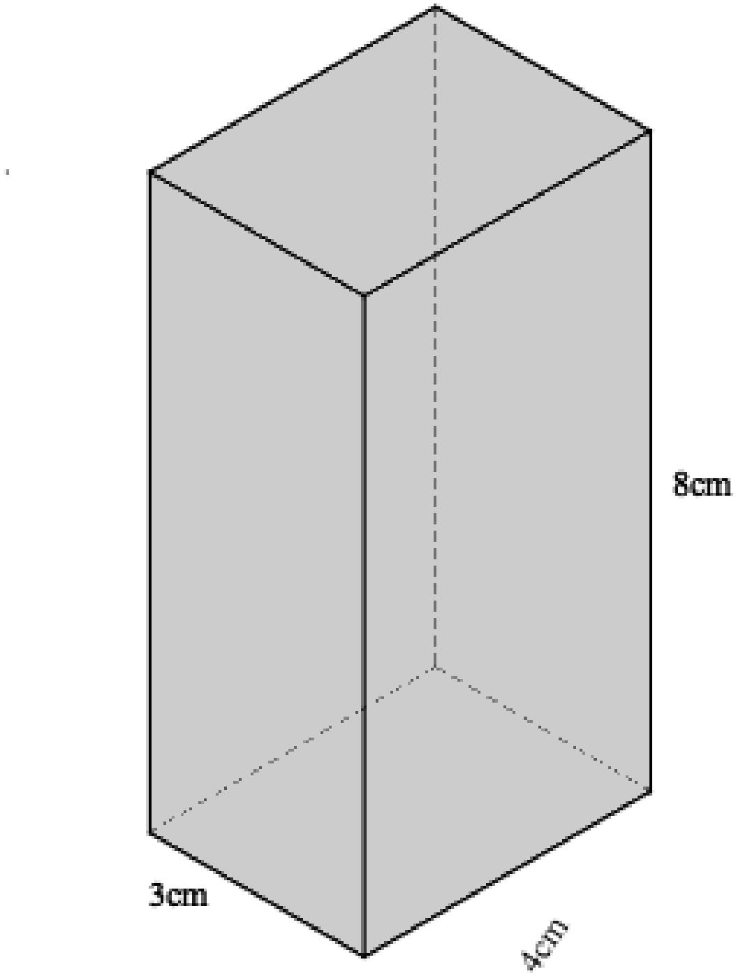

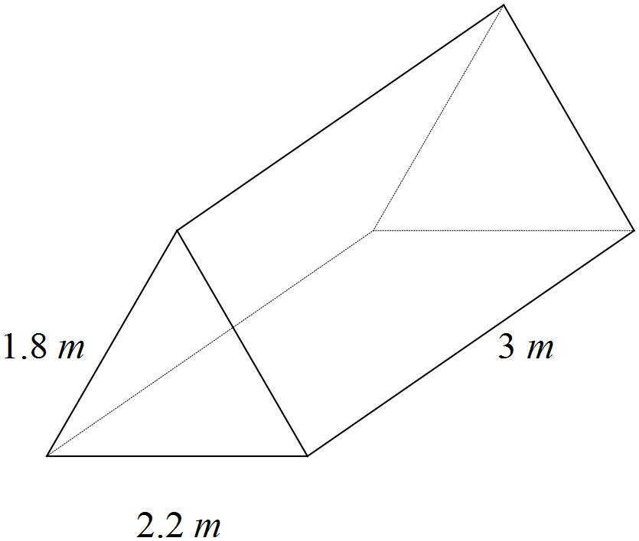

**Question 11** [3 marks: 1, 2]

(a) Calculate the volume of this dice if each face (flat surface) is 2 cm by 2 cm.

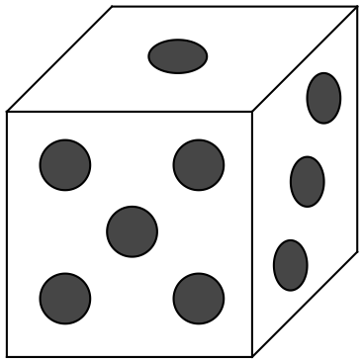

(b) What would be the effect on the volume if all the lengths were doubled?

**Question 12** [6 Marks: 1, 2, 3]

Below are the ingredients for Easy Pancakes. These quantities of ingredients make enough pancakes for 5 serves.

|  |  |
| --- | --- |
| 1 cup all-purpose flour | 1 cup milk |
| 1 egg | 2 tablespoons white sugar |
| 2 tablespoons vegetable oil | 2 teaspoons baking powder |
| 1 teaspoon salt |  |

Josh has his family staying for the long weekend and decides he wants to use this recipe. He has nine (9) of his relatives staying with him.

(a) How many cups of flour would he need to make enough pancakes for himself and his relatives?

(b) The measuring cup Josh has measurements in millilitres. He looks on the internet and finds that **1 cup is equal to 250ml**. How many litres of milk will Josh need?

(c) To help him make the recipe, his cousin Bella, decides to measure out the milk. But Josh is using the only measuring cup. She decides to use a measuring spoon instead. She knows that **1 teaspoon = 5ml**. How many teaspoons of milk will she have to measure out?

**Question 13** [6 marks: 1, 1, 2, 2]

You are building drag car with one of your friends. The fuel tank you choose to use has the dimensions of 670mm by 605mm by 210mm.

1. Draw the tank and label the dimensions.

(b) Calculate the volume of the tank you have drawn.

(c) Find the capacity of the tank to the nearest litre.

(d) The actual capacity of fuel tanks can vary by as much as 3%. This means the tank has the ability to hold 3% more or less than its stated capacity.   
   
Using your answer from part (c), calculate the maximum and the minimum capacity of the tank when there is a 3% variation.

### Question 14 [5 marks: 2, 1, 2]

The formulae for Basic Metabolic Rate are below, giving the result in calories. The weight is measured in kilograms and the height measured in centimetres.

Female BMR (in calories) = 655 + (9.6 x weight) + (1.8 x height) – (4.7 x age)

Male BMR (in calories) = 66 + (13.7 x weight) + (5 x height) – (6.8 x age)

**Calories can be converted to kilojoules by multiplying by 4.182**

Calculate the BMR (in kilojoules) for the following people, showing all your working.

a) A 17 year old male, 172cm tall, weighing 58kg.

b) A 54 year old male, 178cm tall, weighing 73kg.

c) What happens to BMR as people get older? Explain what aspect of the formula causes this.